Chapter 8 programming practice

# disk scheduling algorithm

Given the common.h

## Common.h

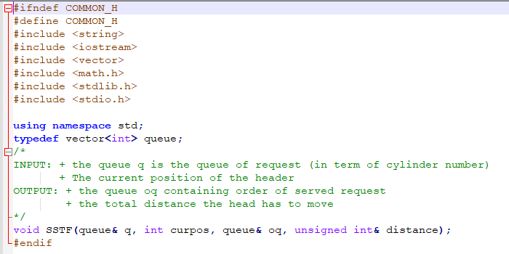

The procedure **SSTF** is the Shortest Seek Time First disk scheduling algorithm.

/*

INPUT: + the queue q is the queue of request (in term of cylinder number)

+ The current position of the header

OUTPUT: + the queue oq containing order of served request

+ the total distance the head has to move

*/

## void SSTF(queue& q, int curpos, queue& oq, unsigned int& distance);

## main.cpp

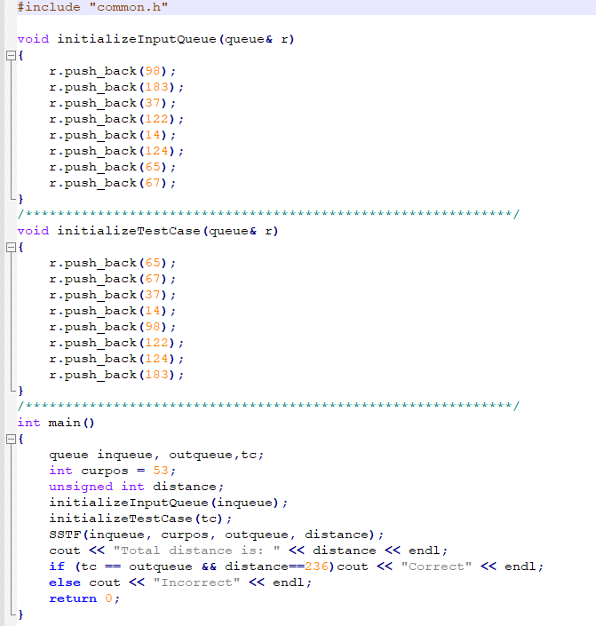

This contains the variable declaration and test case.

## Makefile

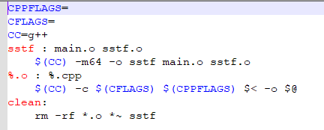

# Problem

Write the void **void SSTF(queue& q, int curpos, queue& oq, unsigned int& distance);** procedure in the sstf.cpp file